Problem No: 01
Problem Name: Convert RGB Image to Grayscale Image and Show Image Matrix
Objectives:
- To understand RGB color images and grayscale images.
- To learn image processing basics using Python.
- To convert an RGB image into a grayscale image.
- To display the pixel matrix of an image.
- To gain practical knowledge of image manipulation using Python libraries.
Theory:
A digital color image is usually represented using the RGB color model, where each pixel contains three color components:
R = Red
G = Green
B = Blue
A grayscale image contains only intensity information instead of color. Each pixel has a single value representing brightness, ranging from:
0 = Black
255 = White
The grayscale value is commonly calculated using the weighted average formula:
Gray=0.299R+0.587G+0.114B
This formula gives more importance to green because the human eye is more sensitive to green light.
Code:
from PIL import Image
import numpy as np
import matplotlib.pyplot as plt

image = Image.open('sm_pic.jpg').convert('RGB')
gray_image = image.convert('L')
gray_matrix = np.array(gray_image)
plt.figure(figsize=(10, 5))
plt.subplot(1, 2, 1)
plt.title('Original RGB Image')
plt.imshow(image)
plt.subplot(1, 2, 2)
plt.title('Grayscale Image')
plt.imshow(gray_image, cmap='gray')
plt.show()
print("Grayscale Image Matrix:")
print(gray_matrix)
Output:
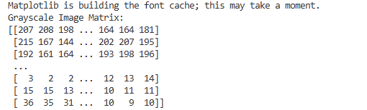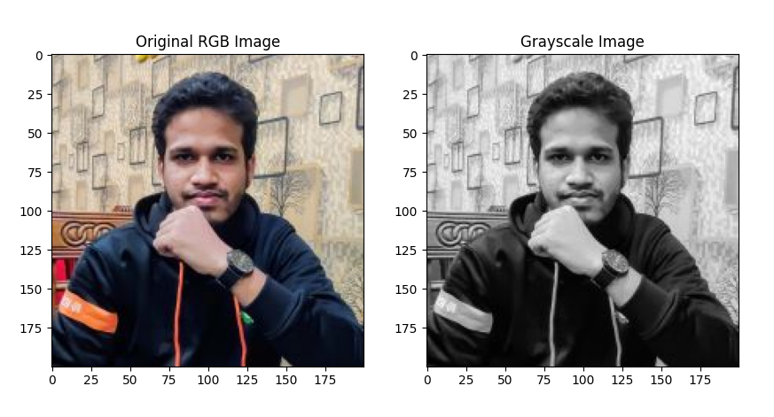

Result & Discussion:
The RGB image was successfully converted into a grayscale image. The grayscale image contained only intensity values, and the matrix displayed the numerical pixel values of the image.

Analysis:
Grayscale conversion reduces image complexity by removing color information while preserving brightness details. This process is important in image processing because grayscale images require less storage and computation.

Opinion:
Through this experiment, I learned how RGB images are converted into grayscale images using intensity formulas. I also understood how image matrices represent pixel values numerically in digital image processing.

